Streaming Talents Documentation

Streaming Talents Big Picture
Streaming Talents is a single-player game that combines life simulation (Streaming Simulation), resource management, and narrative choices.

Players take on the role of a new VTuber, which is a virtual streamer who uses a virtual avatar instead of their real face. They play as them through daily choices in livestream content, social interactions, business collaborations, mental health management, and life organization, gradually building a reputation online while navigating the pressures of the internet, fan expectations, parasocial fans, and corporate profit demands.

Main Gameplay Loop – Day Loop
Wake up → Check status
Prepare → Decide today's actions
Stream → Select topics, interact, respond to messages
Company Tasks → Accept/decline collaborations, ads, projects
Personal Time→ Manage stress, learn skills, socialize
Sleep → Enter the next day

Main gameplay loop:
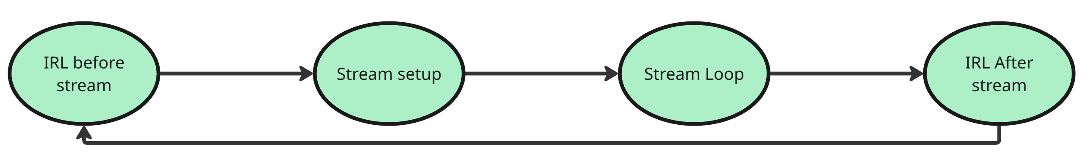
Full Gameplay structure. (To see the individual sections see them in Core Mechanics.)

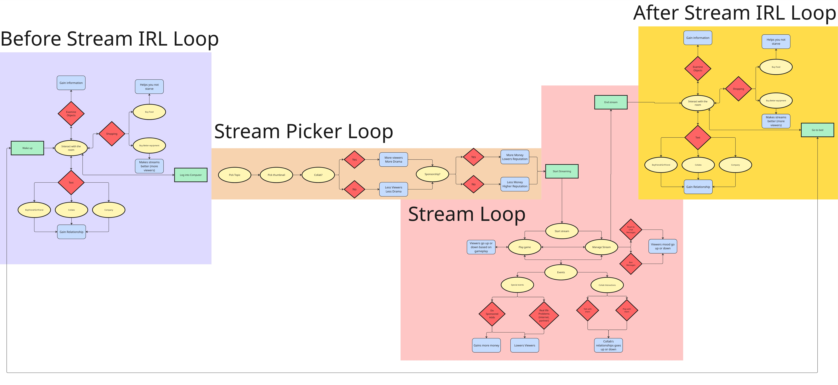

Streaming Talents Design Direction

The Core Pillars
The design direction of this proposed project is composed to three pillars. These three pillars are designated as:
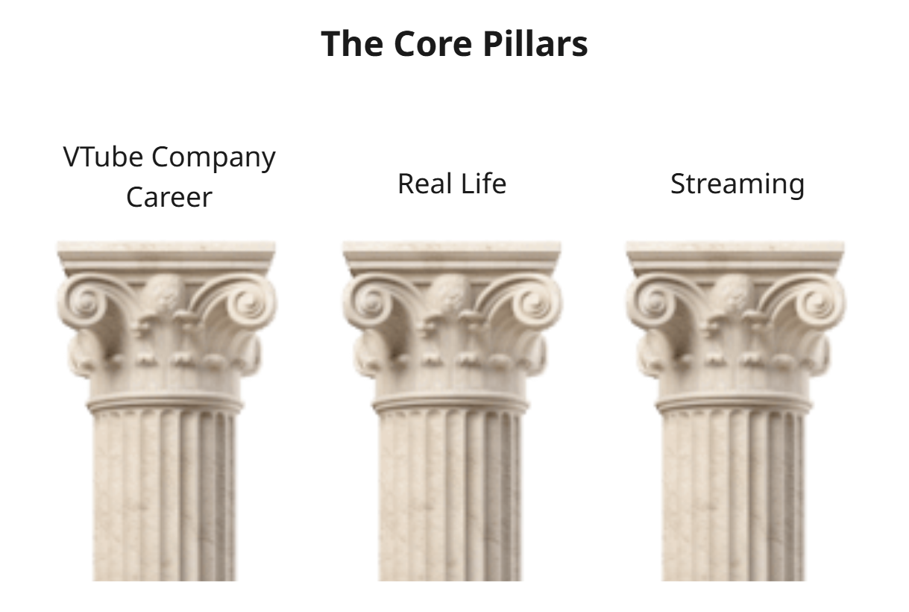
The player in this game will have their very own VTube career offered by a talent agency. The player must manage all the certain mechanics and systems that revolve around this pillar. These systems include the player’s career growth in the online space, their reputation and how they interact with other VTubers. Beyond that, the player must appease their company by bringing in enough growth and money.
When not on the computer, the player must manage their own real life. This goes from expenses, rent and mental health. The player also has their own partner that they are forced to hide from their fans. The player lives in an apartment that they must clean and pay rent for. If the player does not take care of themselves, their mental health and work performance will falter.
Streaming is another core pillar of the game. The player as a VTuber has their own 3D model that they stream with. The player has their own stream chat, who the player must manage unless they get out of control. Along with this, on the player must play a series of minigames during the stream. Before the stream, the player can do a series of options to set up the stream. These can result in a positive or negative outcome.

Design Razors
A common part of working with people, especially in a team are conflicts. Conflicts can divide or seriously damage both teams and projects. However, in a high-pressure environment? It can destroy a project. To help address these conflicts, we created a series of actions we can choose to mitigate arguments and tension between peers.
- Dot Voting
Dot voting helps to add a sort of democracy to the team. People anonymously select what their preferred option and based on that the decision is made. However, if someone is the feature owner, they have the final say.
- Take a break/walk
Taking a break/walk can calm down the mind before anything rash is said or done. If something rash happens, it can create further conflict.
- Allow peers to both explain sides fully
Interrupting someone’s flow of thought or speech can distract and entirely overwrite someone’s idea. Allowing someone in a conflict to express their full intentions and reasons behind it can help find a decision or a common ground between team members.

Criteria
Our criteria for our game's success are built upon the player’s transformation and response to the gameplay. Our goal here is to educate the player and help them empathize with VTubers (and live streamers) that work in the industry. Players don’t necessarily have to sympathize, but the focus is still on educating and helping the players empathize with VTubers is still relevant. Therefore, our criteria remain that if players are transformed through our project by education, then it is considered a success.

Streaming Talents Core Mechanics
The core mechanics of Streaming Talents revolve around a continuous daily cycle. Involving tending to real life activities, streaming, and dealing with both the company and fans.

Each day, players determine their course of action based on their follower count, income, reputation, and psychological stress levels. The day begins by displaying the previous day's outcomes and status changes, prompting players to choose their streaming approach for the day—whether casual chatting, following trending topics, or collaborating with other VTubers in their company. Each streaming type carries distinct rewards and costs, determined by the player's specific choices. For instance, some may yield substantial income but increase stress levels. Or raise up their reputation but lower their income. These decisions force players to constantly balance “authenticity” against “profitability.”

Live streaming forms core gameplay. Audience comments appear in real-time, ranging from encouragement and requests to criticism or emotional dependency. Player responses to these comments directly impact stress levels, fan reactions, and public image. Alongside these comments, they will also have to deal with whatever else they are doing on stream, whether it’s playing a new game or talking about the latest drama.

After signing off, players review daily fan growth, earnings, and stress fluctuations before entering Personal Time. During this period, players may choose to rest, exercise, go out, etc. Different leisure activities reduce stress, improve mood, or enhance streaming skills. These “self-management” choices form another crucial loop, requiring players to not only cultivate their character image but also maintain their own physical and mental sustainability.

Simultaneously, players must navigate the tension between “catering to the market” and “staying true to themselves.” As the game progresses, conflicts arising from audience expectations, corporate demands, trends, and personal values gradually shape the protagonist's trajectory. Ultimately, players' choices determine whether they evolve into a highly commercialized online idol or a sincere yet vulnerable creator. This interwoven system aims to authentically convey the daily pressures, temptations, growth, and sacrifices experienced by online creators.

IRL Gameplay Loop (Before and after stream)
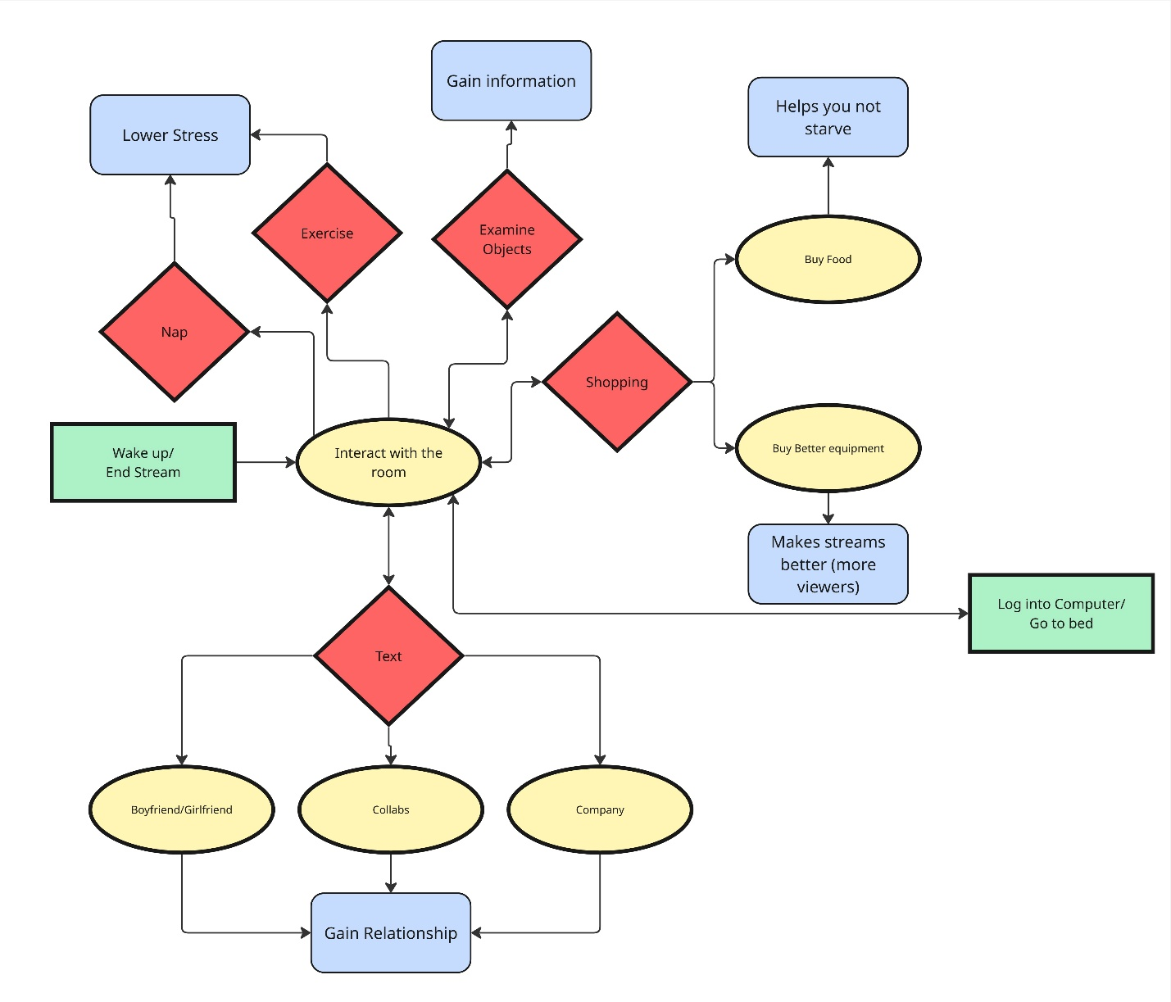

Stream Set-up Loop (Before the stream)
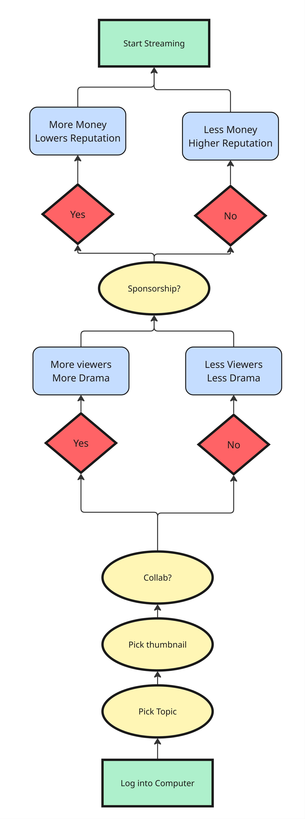

Streaming Loop (During the stream)
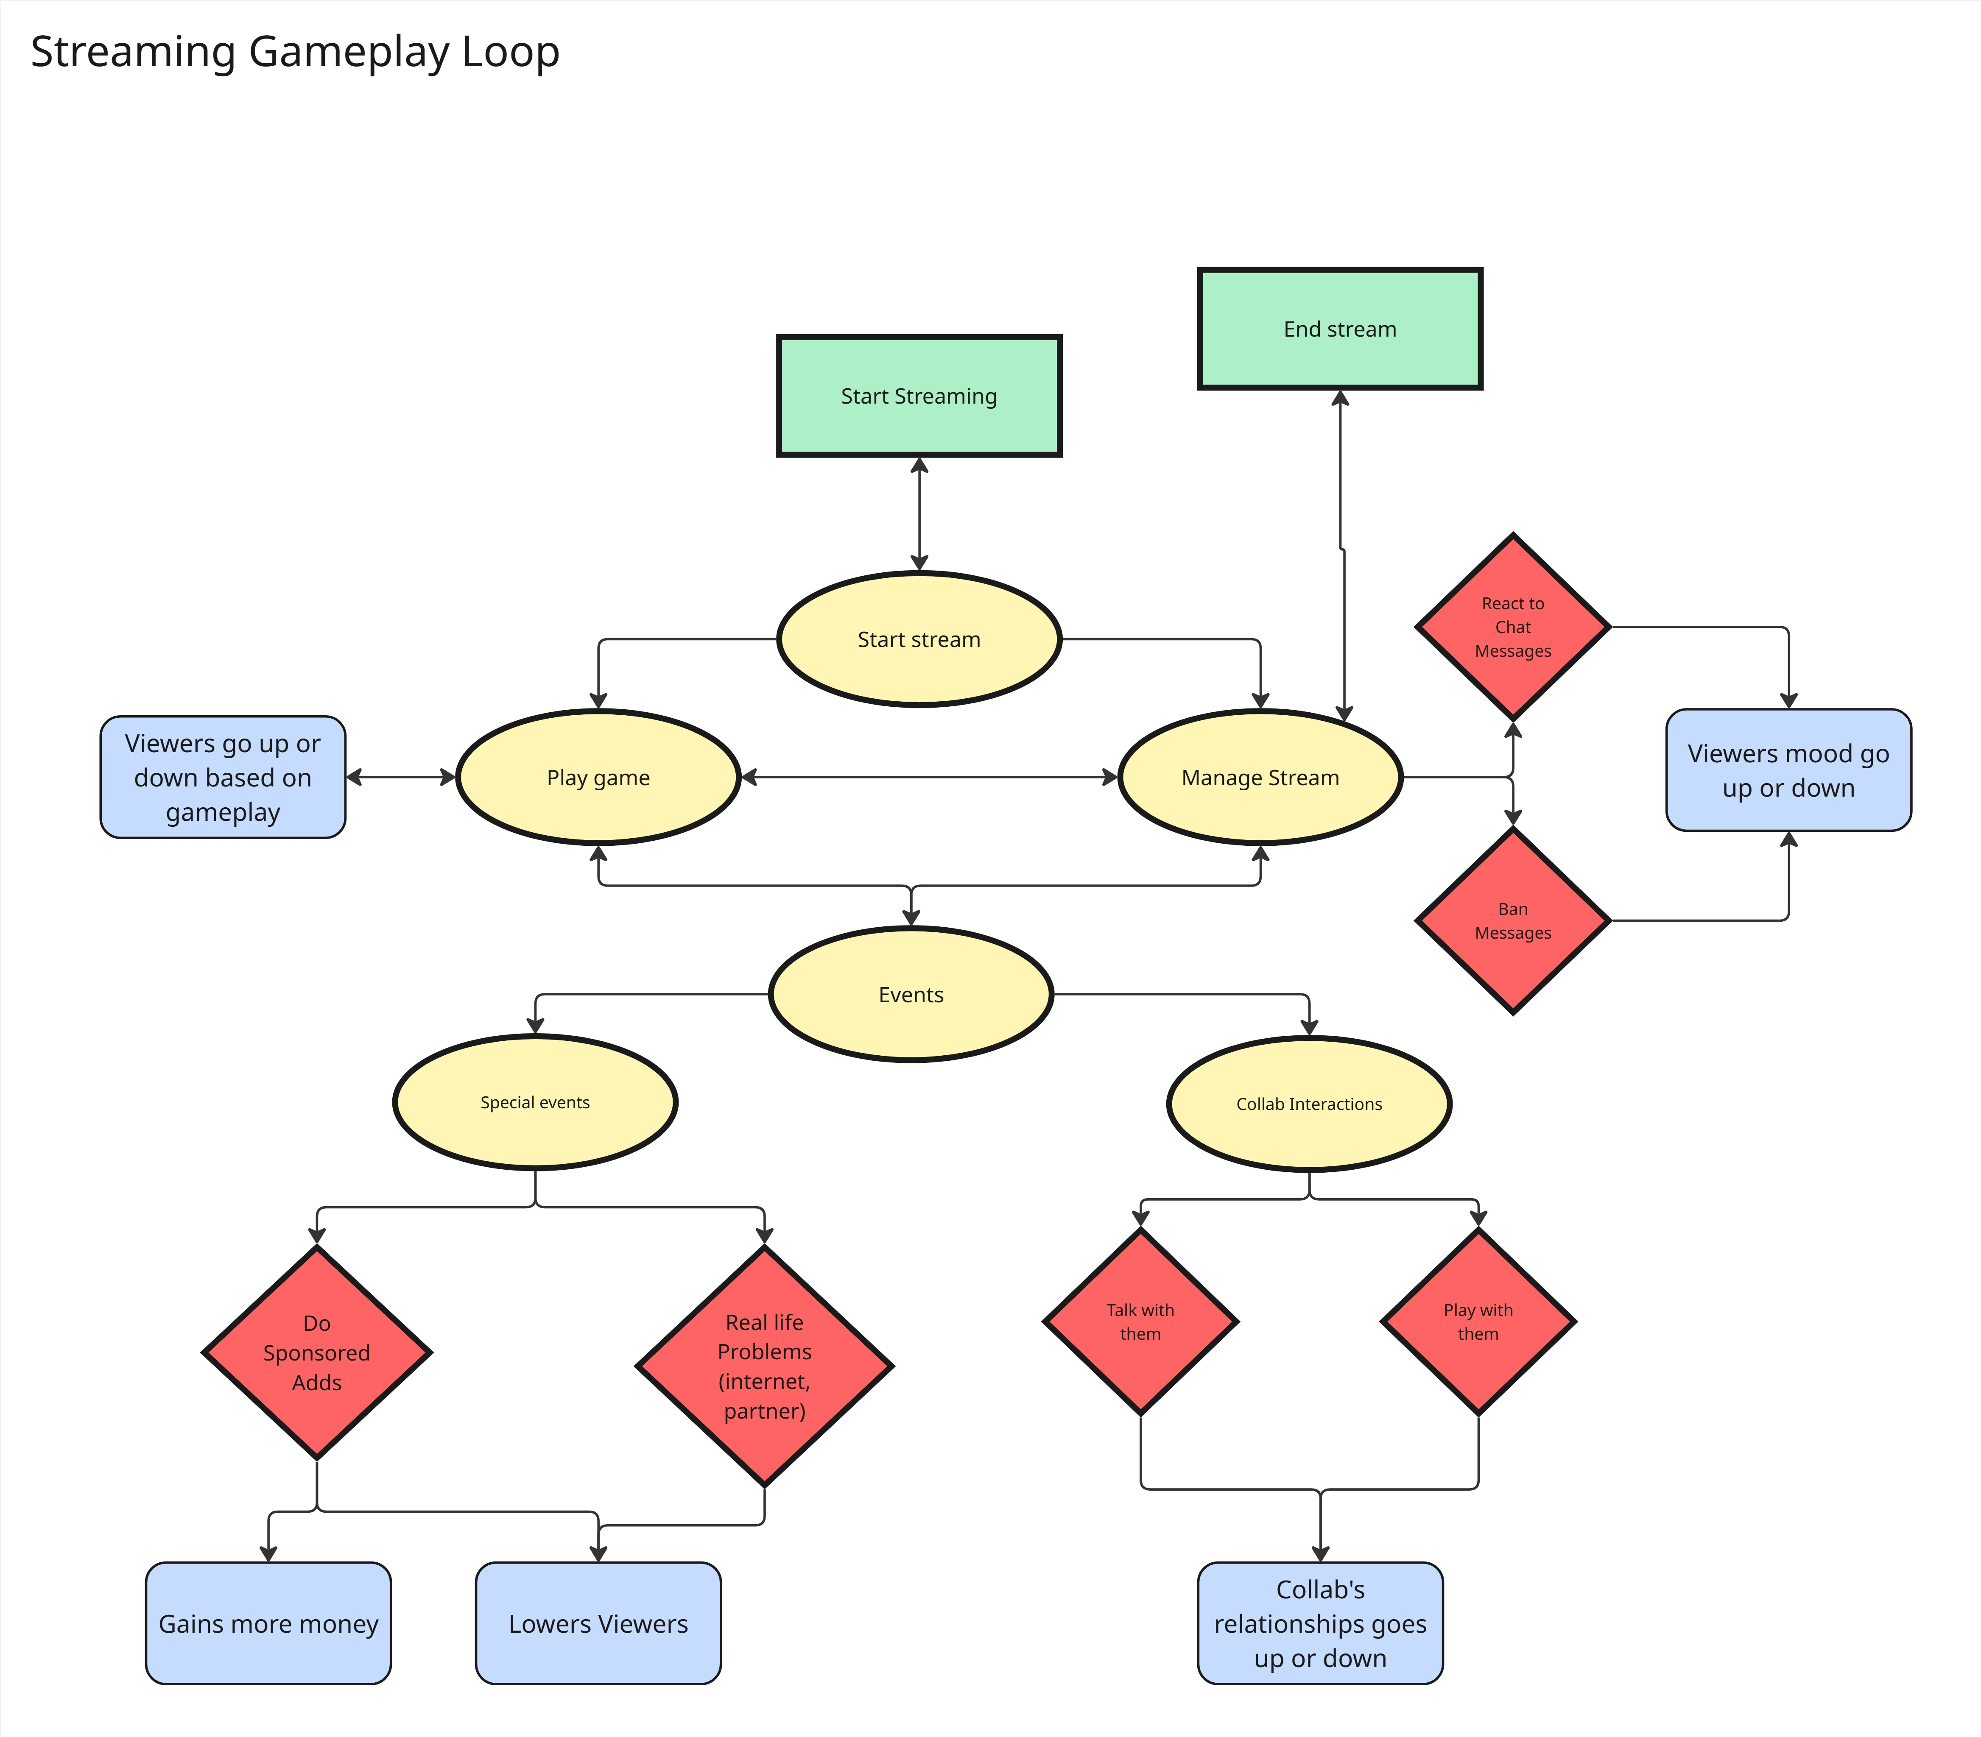

Streaming Talents Complete Scope

Planned Features

Life Work Balance, Time Management
- Day Cycle
- Time System
  - A Time Limit (Quota)
  - Time Given in Hours
  - Time Changes:
    - Streaming removes hours
      - Adds & Stress Popularity
    - Doing IRL activities removes hours
      - Removes Stress
- IRL (3D first person interactive)
  - 3D Vtuber Model
  - Interactive environment
    - Dialogue popups
  - Stress system
  - Additional Activates
    - Exercise
    - Napping
  - Texting system with collabs and boyfriend/girlfriend
- Collab Vtuber Socialization
  - Decide which collab to talk to
    - Increases chemistry
    - Removes stress based on chemistry

Popularity vs Reputation Management
- Streaming Decisions
  - Collab
    - 4 choices
  - Sponsor
  - Charity
  - Stream Type (Will change chemistry with collabs depending on choice)
    - Games
    - ASMR
    - Singing
    - Talking
- Streaming Game
  - Interactions with 2D/3D Games
  - Managing Comments
    - Comments spanning system
    - Responding to comments
    - Removing/Banning comments
    - Super chats and donations
  - Interacting with collabs

Priority List
For our priorities, we created a list from 1 to 9 to what we considered the most important features/mechanics for the game:
- Streaming
- Company Quota
- Story
- Real Life / Apartment Area
- Stream Chat System
- Partner Story
- Stream decisions/setup
- Rent / Expenses and revenue
- Collab System and Socialization

